**SSN COLLEGE OF ENGINEERING, KALAVAKKAM  
DEPARTMENT OF COMPUTER SCIENCE AND ENGINEERING  
UCS1712 – GRAPHICS AND MULTIMEDIA LAB ------------------------------------------------------------------------------------------------------------**

**Lab Exercise 4 : Midpoint Circle Drawing Algorithm in C++ using OpenGL**

**Aim:**

To plot points that make up the circle with center (xc,yc) and radius r using Midpoint circle drawing algorithm

**Algorithm:**

1. Input radius r and circle center (xc, yc ). set the first point (x0 , y0 ) = (0, r ).
2. Calculate the initial value of the decision parameter as p0 = 1 – r.
3. At each xk position, starting at k = 0, perform the following test:  
   If pk <0,  
   plot(xk +1,yk )and pk+1 =pk +2xk+1 +1,

Else,

1. plot(xk +1,yk -1)and pk+1 =pk +2xk+1 +1-2yk+1,

Where 2xk+1 =2xk +2and2yk+1 =2yk –2.

**Source Code:**

| #include<GLUT/glut.h> #include<iostream> #include<string> #include<cmath> using namespace std; void drawString(float x, float y, const char *string) {  glRasterPos2f(x, y);  for (const char *c = string; *c != '\0'; c++) {  glutBitmapCharacter(GLUT_BITMAP_HELVETICA_12, *c);  } } void myInit() {  glClearColor(1.0,0.6,0.5,0.0);    glPointSize(1);  glMatrixMode(GL_PROJECTION);  glLoadIdentity();  gluOrtho2D(-320.0,320.0,-240.0,240.0); } void plototherwc(int x,int y,int c1,int c2){  glBegin(GL_POINTS);  glVertex2d(-x+c1,y+c2);  glVertex2d(-x+c1,-y+c2);  glVertex2d(x+c1,-y+c2);  glVertex2d(y+c1,x+c2);  glVertex2d(-y+c1,x+c2);  glVertex2d(-y+c1,-x+c2);  glVertex2d(y+c1,-x+c2);  glEnd(); } void myDisplay() {  glClear(GL_COLOR_BUFFER_BIT);  int c1,c2,r,p,x,y;  cout<<"Enter co-ordinates of centre : ";  cin >> c1 >> c2;  cout<<"Enter radius: ";  cin>>r;  p=1-r;  cout<<"Start Point : (0,"<<r<<")\nP0 = "<<p<<endl;    x=0;  y=r;  glBegin(GL_POINTS);  glVertex2d(x+c1,y+c2);  glVertex2d(x+c1,-y+c2);  glVertex2d(-y+c1,x+c2);  glVertex2d(y+c1,x+c2);  glEnd();  while(x<=y){//initially condition was x<y changed to x<=y  if(p>=0){  x=x+1;  y=y-1;  p=p+(2*x)-(2*y)+1;  glBegin(GL_POINTS);  glVertex2d(x+c1,y+c2);  glEnd();  plototherwc(x,y,c1,c2);  }  else{  x=x+1;  p=p+(2*x)+1;  glBegin(GL_POINTS);  glVertex2d(x+c1,y+c2);  glEnd();  plototherwc(x,y,c1,c2);  }  }  glFlush();    } int main(int argc,char* argv[]) {  glutInit(&argc,argv);  glutInitDisplayMode(GLUT_SINGLE|GLUT_RGB);  glutInitWindowSize(640,480);  glutCreateWindow("Midpoint Circle Drawing Algorithm");  glutDisplayFunc(myDisplay);    myInit();  glutMainLoop();  return 1; } |
| --- |

**Output:**

**Case (i) : Circle center as origin i.e (0,0)**

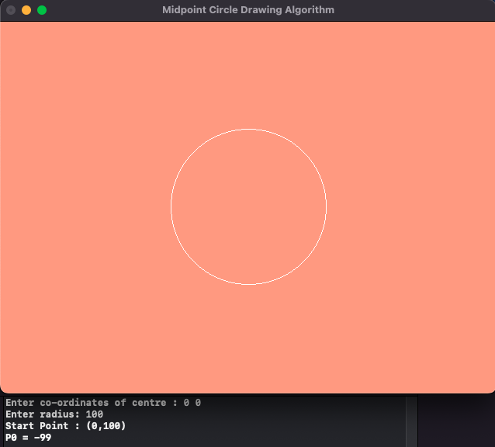

**Case (ii) : any arbitrary point as a center**

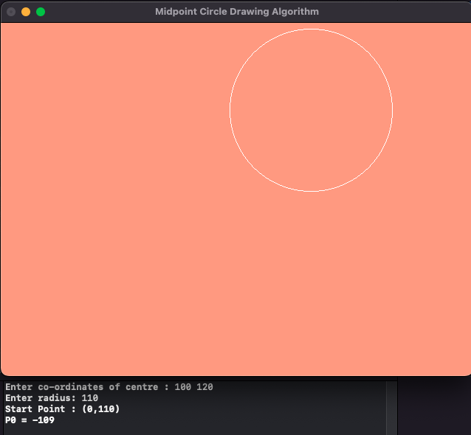

**Learning Outcome:**

Learnt how to perform Midpoint circle drawing algorithm in C++ using OpenGL